PRACTICE 4
Determine the validity of the following three statements. Circle either True or False.
1. Group functions work across many rows to produce one result per group.
True/False
2. Group functions include nulls in calculations.
True/False
    - The WHERE clause restricts rows prior to inclusion in a group calculation.
True/False
The HR department needs the following reports:
4. Find the highest, lowest, sum, and average salary of all employees. Label the columns
Maximum, Minimum, Sum, and Average, respectively. Round your results to the nearest whole number.
- Display the minimum, maximum, sum, and average salary for each job type. 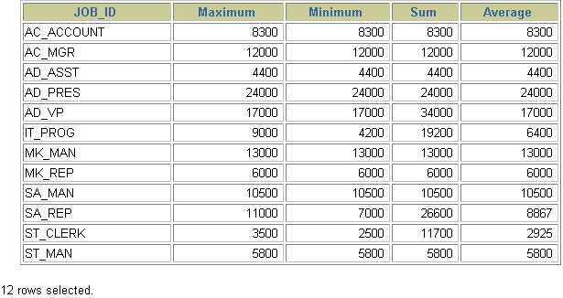
- Write a query to display the number of people with the same job.
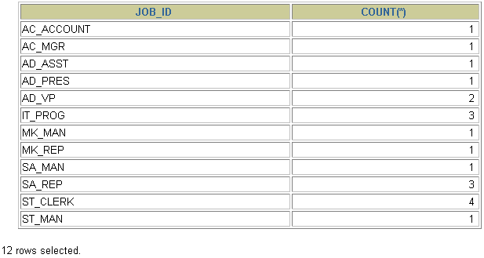
7. Determine the number of managers without listing them. Label the column Number of Managers. Hint: Use the MANAGER_ID column to determine the number of managers.
8.Find the difference between the highest and lowest salaries. Label the column DIFFERENCE.

